Shashank K

SE21UCSE198

CSE 3

DAA Assignment -3

**Goal :** Comparing the number of times the values of max and min are over written

**Without using divide and conquer method**

**Function :**

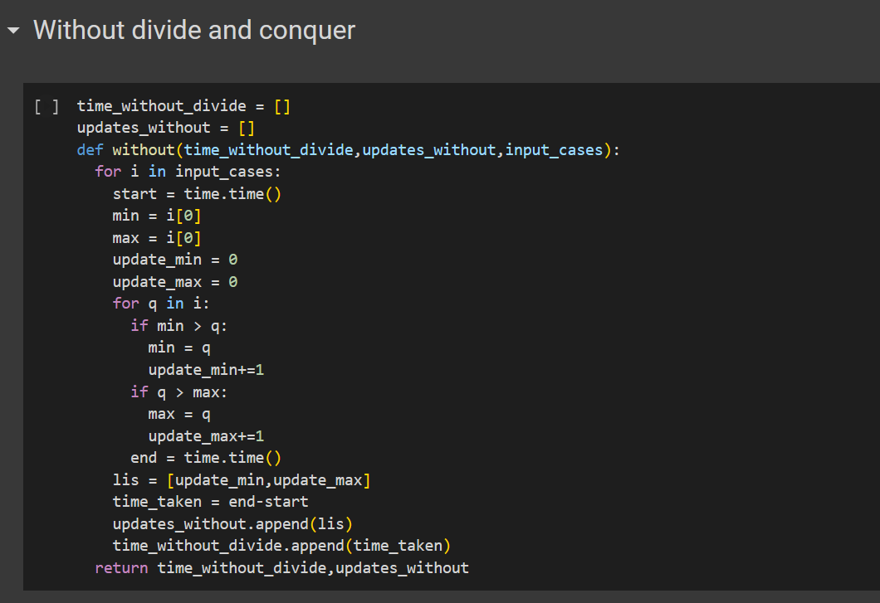

**With using divide and conquer method**

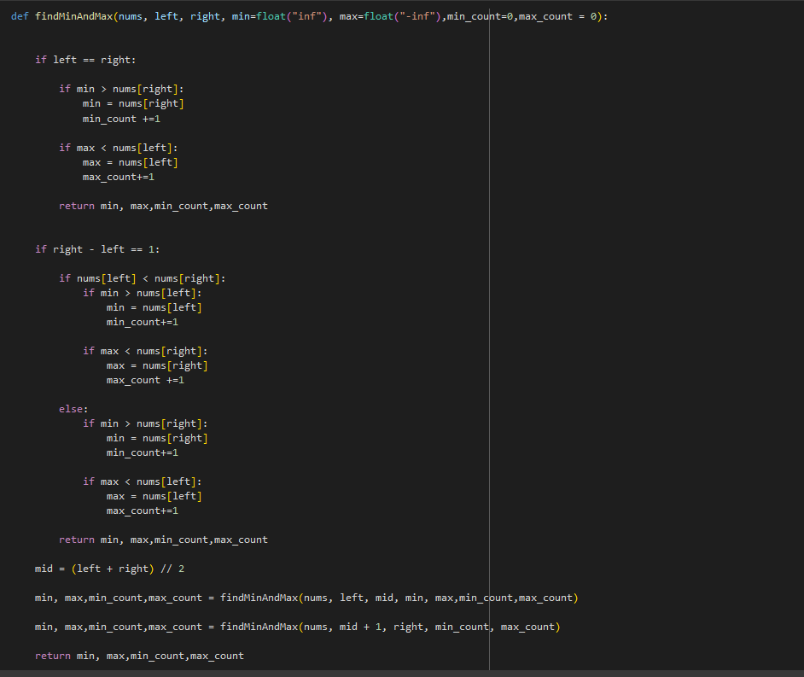

**Results:**

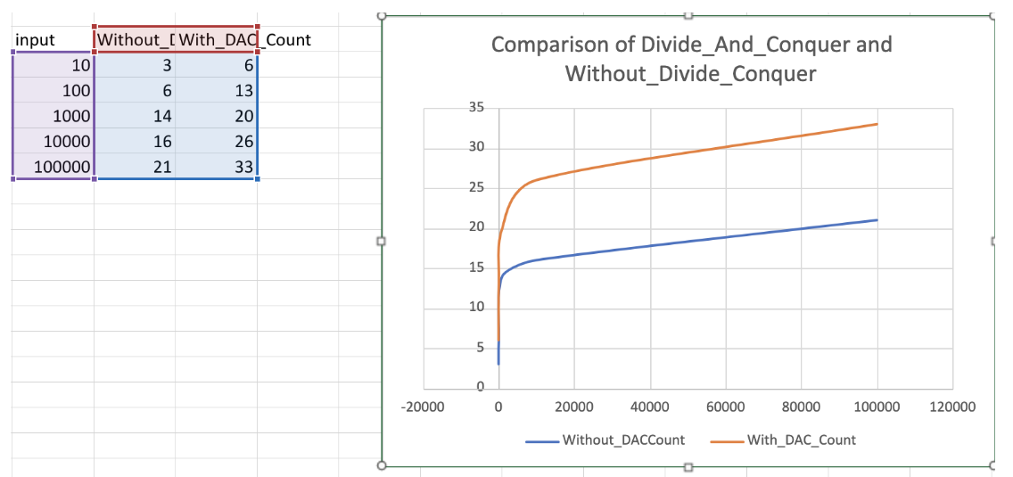

**Conclusion**

Seeing the number of updates, using without divide and conquer

approach is much feasible and optimal than with using divide and

conquer.

Considering space complexity, without_divide_and_conquer is much

feasible than the with_divide_and_conquer, because

with_divide_and_conquer using much more space than the

without_divide_and_conquer.